Speed
Speed is a measure of how fast an object is moving.
Speed shows how far something can travel in a set amount of time.
A car on the freeway will move 100km every hour so its speed is 100 kilometres per hour(Km/h)
Two common units of measure for speed are meters per second (m/s) and kilometres per hour(km/h)
Examples
Object | Speed
Cheetah running  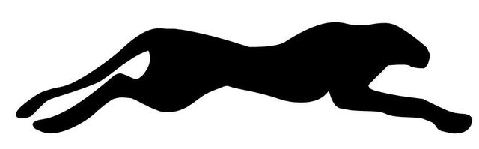 | 110km/h
Bugatti Veyron sports car  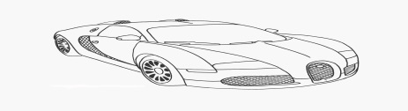 | 400km/h
Average speed of a bullet from a gun | 1700km/h
Jet aeroplane travelling as fast as sound  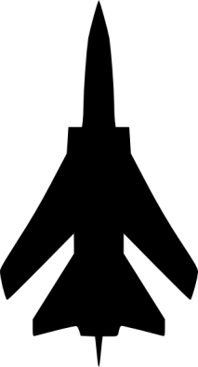 | 343m/s
Golf ball  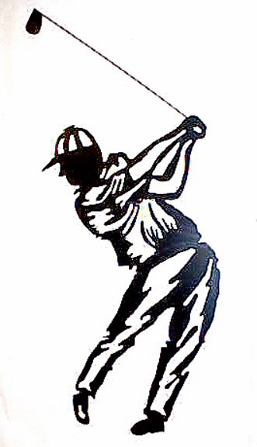 | 60 m/s
Speed is a measure of how _________ an object is moving.
Speed shows how _____ something can travel in a set amount of ____________.

